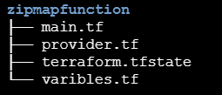

/ variables.tf defines the input lists.

/ main.tf uses **zip map** to create a tags map from those lists and assigns the map to the AWS security group.

**zip map Works:**

* zipmap (var.tag_keys, var.tag_values):
* The zipmap function combines two lists (tag_keys and tag_values) into a map.
* Each element in the tag_keys list is paired with the corresponding element in the tag_values list, creating key-value pairs.

tag_keys = ["Environment", "Project", "Owner"]

tag_values = ["Development", "terraform-zipmap", "Balu"]

tags_map = zipmap(tag_keys, tag_values)

